
Asian School of Management and Technology
(Affiliated to Tribhuvan University)
Gongabu, Kathmandu
Full Marks: 60
Time: 3 Hrs.
SET A
Pre-Board Examination 2080
BIM / Third Semester / IT 238: Data Structure and Algorithms

Candidates are required to answer the question in their own words as far as practicable.
Group "A"
Brief answer questions:
Attempt all questions. (10 X 1=10)
- What do you mean by correctness of an algorithm?
- Define time complexity?
- What are the applications of stack?
- List any three applications of priority queue.
- Define tail recursion.
- Define full binary tree.
- What do you mean by greedy algorithm?
- What is internal sorting?
- Write down the importance of hashing.
- Define min-heap with example.
Group "B"
Short Answers Questions
Attempt any five questions. (5 × 3= 15)
- Explain Best, Average and Worst-Case analysis.
- How stack can be consider as an ADT.
- Write a function/method for enqueue operation in Circular queue.
- Write recursive function of Fibonacci series.
- Explain topological sort with example.
- Write algorithm of tree traversal.
Group "C"
Long Answer Questions
Attempt any three questions. (3× 5= 15)
- Write functions of insertion and deletion a node in doubly linked list.
- Trace binary search algorithm: 5, 2, 8, 17, 23, 9, 11, 78, 12, 25, 98, 75 searching item is: 50
- Store {10, 11, 12, 14, 15, 17} into a hash table size 5. Apply linear probing and double hashing.
- Find the all pair shortest path:
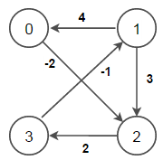
Group "D"
Comprehensive Questions
Attempt all questions. (2 × 10 = 20)
- Why it is necessary to balance the binary search tree? Construct AVL tree: 24, 12, 8, 15, 35, 30, 57, 40, 45, 78
- List out the application of minimum spanning tree. How Kruskal’s algorithm differ from Prim’s algorithm? Construct the minimum spanning tree using prim's algorithm
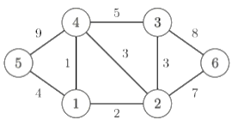


Asian School of Management and Technology
(Affiliated to Tribhuvan University)
Gongabu, Kathmandu
Full Marks: 60
Time: 3 Hrs.
SET B
Pre-Board Examination 2080
BIM / Third Semester / IT 238: Data Structure and Algorithms

Candidates are required to answer the question in their own words as far as practicable.
Group "A"
Brief answer questions:
Attempt all questions. (10 X 1=10)
- What is definiteness of an algorithm?
- What are the operations in Linked list?
- List the benefits of priority queue.
- Define excessive recursion.
- What is B-tree?
- Define heap.
- What do you mean by external sorting?
- Define expression tree with example.
- What do you mean by shortest path problem?
- How can you resolve the collision in hash table?
Group "B"
Short Answers Questions
Attempt five questions. (5 × 3= 15)
- What is complexity of algorithm? Explain
- How queue can be consider as an ADT.
- Write an algorithm to insert an item in specified position of doubly linked list.
- What are the benefits of binary search over linear search algorithm?
- Define binary search tree. Explain the process of deleting data from binary search tree.
- Construct Max-heap 78, 25, 72, 18, 67, 11, 50, 30, 31
Group "C"
Long Answer Questions
Attempt any three questions. (3× 5= 15)
- Write an algorithm of insertion and deletion a node in circular singly linked list.
- Insert a data 12, 8, 7, 18, 20, 17, 19 and 22 into Hash table size 10
- Convert the infix expression to postfix expression: A+B-(C*D/E+F)-G*H.
- What is the complexity of quick sort? Sort the following data using quick sort
4, 7, 2, 6, 1, 4, 7, 3, 5, 2, 6
Group "D"
Comprehensive Questions
Attempt all questions. (2 × 10 = 20)
- Differentiate between binary search tree and multiway search tree? Construct B-tree of order 5 for following data values: 20, 40, 80, 30, 120, 90, 50, 140, 110, 60, 100, 200, 190, 250, 60, 130, 220, 170.
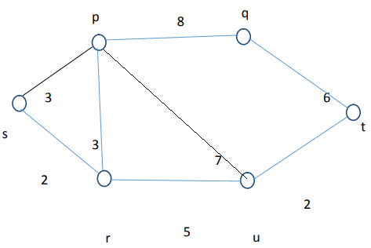
- List out the application of minimum spanning tree. How Kruskal’s algorithm differ from Prim’s algorithm? Find the shortest path from node a to node t from following graph by using Dijkstra algorithm.

